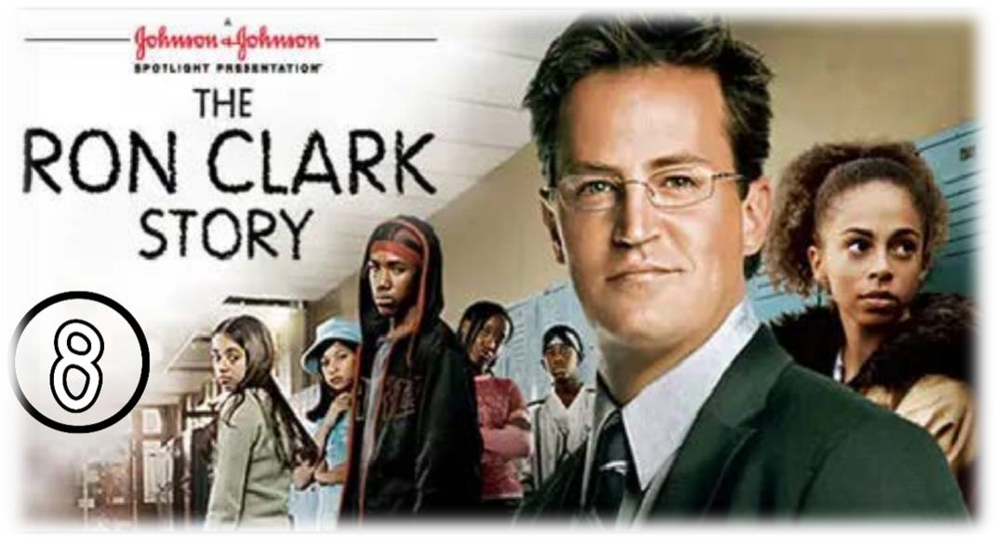

SCENE PPARATION

Scene summary: copy – paste
At the beginning of the scene, we see Mr. Clark helping Tayshawn and Julio who have problems in Math and English . He invites them to the coffee shop to provide support and to bring up additional information . Finally, he goes to see Shameika at home to help her with her homework but Shameika's mother kicks him out because Mr. Clark did not ask her permission.

Scene Discussion & Analysis:
- Q01: Who is Tyshawn? And what does he look liked?
- Tyshawn is Mr. Clark’s student . He is a young dark skinned teenager with dark eyes . He is tall and slim with short dark hair . he always wears baggy clothes .
- Q02: Did he show up at the coffee shop on time?
No , he didn’t .
- Q03: Who showed up instead?
- Julio showed up instead .
- Q04: Based on your comprehension, why was Mr. Clark inviting his students to the coffee shop?
- Mr. Clark was inviting his students to the coffee shop to help them improve their scores in English and Math .
- Q05: Did Shameka turn her homework on time? Why (based on your understanding)
- No , she didn’t . She didn’t have enough time because she was in charge of her siblings and house hold chores .
- Q06: Do you think that Mr. Clark had the right to go into Shameka’s house without her mom’s permission? Do you agree with him?
We think that Mr. Clark doesn’t have the right to go to Shameka’s house without her mother’s permission because it is impolite , and risky . Mr. Clark can face major consequences because Shameka is a young girl , she is underage and Mr. Clark remains stranger to her outside the school . We can understand that Mr. Clark’s intention is pure . He knows that shameka is dealing with some personal issues that are distracting her from studying . He couldn’t help her in the right way if he didn’t go and witness what she is though .

Acquired Vocabulary (OPTIONAL):

► To bring up (level):
    - Example in a sentence:
“ We study hard to bring up our level in English “
► To show up
    - Example in a sentence:
“ BeforeTwo days , we showed up at her house “

► Fussy
    - Example in a sentence:

« Mr. Clark finds it hard to teach his fussy students “

Irregular Verbs:

Infinitive | Past simple | Past participle
To tell | told | Told
To forget | Forget | Forgotten
To bring | Brought | Brought
To buy | Bought | Bought

ADDITIONAL EXERCISE (OPTIONAL)

Task: Transcribe sentences from the scene.
- Transcribe Sentence 01
You could bring up your math and English with some extra help. Tomorrow Saturday, I can meet you at the coffee shop by the school. I’ll buy you lunch.
- Transcribe Sentence 02
- Didn’t we have an appointment after school today?
- Must have slipped my mind. : I forgot

- Transcribe Sentence 03
I tried like you said, I moved the third paragraph and it sounds really good .

